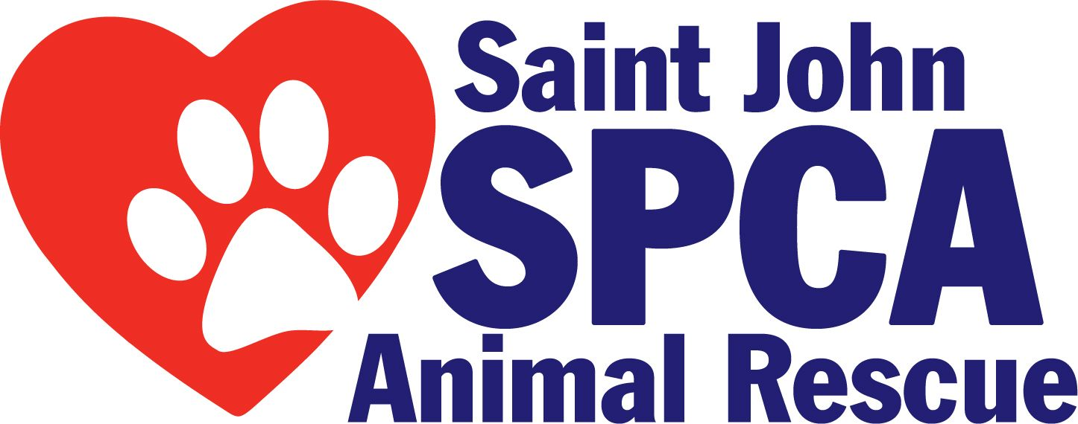

295 Bayside Drive, Saint John, NB, E2J 1BI Phone 642-0920 Fax 634-6101

Landlord Consent Form

This is to confirm that __________________________________, the landlord of
(print name)

____________________________________________________, gives permission to
(print address)

____________________________________________________, at the above address to adopt a
(name of tenant)

__________________ from the SPCA Animal Rescue. The tenant has signed an agreement with the shelter which says he/she agrees to spay/neuter, keep up to date vaccinations, and license the animal(s).

Please be aware that if your tenant moves or is evicted and abandons an animal, as the landlord you are responsible for that animal (s). It is up to you to notify the New Brunswick SPCA if this occurs.

__________________________________________ Date ________________________
Signature of Landlord

Address: ___________________________________ Telephone: ___________________

(Revised March 2014)

